Front-end:

Streamlit

Back-end:

Flask

Chat Bot(Rule Based) Working:

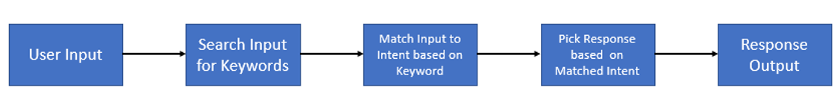

Chat Bot Training Table:

|  |  |  |  |  |
| --- | --- | --- | --- | --- |
| Tooth Decay | Diarrhea | Cough | Diarrhea_short_watery | Indications |
| 1 | 0 | 0 | 0 | Dental Health |
| 0 | 1 | 0 | 1 | Digestive Health |

Database for Medicine

|  |  |  |  |  |
| --- | --- | --- | --- | --- |
| Indications | Reaction with Allergies | Reacts with Medicine | Not Suitable for Conditions | Medicine Name |
| Digestive Health | N/A | N/A | Heart Disease | Flagyl |
| Dental Health | Skin Rash | Panadol | N/A | Listerine |

. . . . . . . . . . . . . . . . . . .

Libraries and Packages:

**-**re for regular expression and wordnet

-NLTK(Natural Language ToolKit) nltk.corpus

Chat Bot Decision Tree

. . . . . . . . . . . . . . . . . . .

. . . . . . . . . . . .